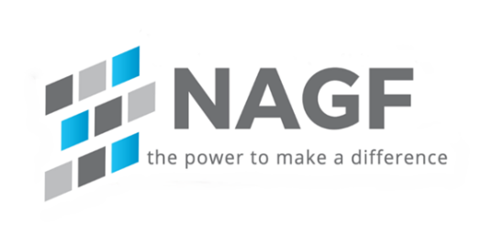

NAGF Markets and Policy Working Group
February 25, 2026, 1:00 – 2:00 PM EST Webinar Agenda

Agenda:

- Chair
  - Steve Casey

- Reliable Power Act (H.R. 3616) As of late December 2025, the Reliable Power Act (H.R. 3616) passed the U.S. House of Representatives with a 225-203 vote on December 17, 2025, and has been referred to the Senate Committee on Energy and Natural Resources. Introduced by Rep. Troy Balderson, the bill requires federal agencies to analyze the impact of new regulations on electric grid reliability before finalizing them

- Key Details on H.R. 3616 Status:
- Passed House: Passed on Dec. 17, 2025.
- Senate Status: Received in the Senate and referred to the Committee on Energy and Natural Resources.
- Purpose: To prevent federal agencies from implementing rules that threaten the reliability of the nation's electric power grid.
- Key Provisions: Requires the North American Electric Reliability Corporation (NERC) to conduct annual assessments, allowing the Federal Energy Regulatory Commission (FERC) to intervene if regulations risk power supply shortfalls.
- The bill is part of a broader effort to ensure energy security and prevent electricity shortages.

- MSPPTF Final Recommendations
- Click here for: Final Recommendations | Summary | Process Map

- Operational Focuses for this quarter
- Cold Weather preparation and ensuring generation availability
- Natural Gas availability

- Open Discussion

