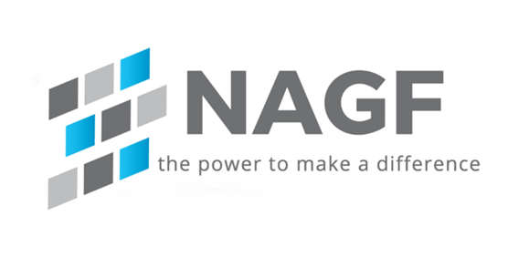

PRC-029 Implementation Guidance
Frequency and Voltage Ride-through Requirements for Inverter-based Resources
Requirement R4

Date 10/16/2025

Table of Contents
Introduction 3
Goal/Problem Statement 3
Scope 3
Reliability Standard 3
Requirement R4 3
Periodic Review 4

Introduction
This document provides guidance related to how Registered Entities can determine if their IBRs are eligible to submit and receive an exemption under PRC-029-1 based on the criteria identified in the Standard. As critical terms used in the criteria were not defined during the Standard Drafting process, it is necessary that entities use a sound and consistent basis to determine how the term “in-service” should be applied when assessing eligibility for exemptions under Requirement R4.

Goal/Problem Statement
Generator Owners have observed that undefined terms appear in the PRC-029-1 Standard language that will lead to confusion and inconsistent application among entities. This Implementation Guidance seeks to provide Registered Entities with an approach that can be used to establish a sound basis for applying criteria in PRC-029 that uses undefined terms, similar to the approach that has been widely used to determine the “commercial operations date” as used in the ERO Enterprise Registration Procedure.

Scope
The following Implementation Guidance applies to Generator Owners that own IBRs who are seeking to determine eligibility for known hardware limitation exemptions that prevent the IBR from meeting Ride-through criteria as detailed in Requirements R1-R3.

This Implementation Guidance does not guarantee compliance and is based on precise language of the standard, individual facts, circumstances, system configuration, quality of evidence, etc.

Reliability Standard

1. Title: Frequency and Voltage Ride-through Requirements for Inverter-based Resources
2. Number: PRC-029-1
3. Purpose: To ensure that IBRs Ride-through to support the Bulk Power System (BPS) during and after defined frequency and voltage excursions.

Requirement R4
R4. Each Generator Owner identifying an IBR that is in-service by the effective date of PRC029-1, has known hardware limitations that prevent the IBR from meeting Ride-through criteria as detailed in Requirements R1-R3, and requires an exemption from specific Ride-through criteria shall:

4.1. Document information supporting the identified hardware limitation no later than 12 months following the effective date of PRC-029-1. This documentation shall include:
4.1.1 Identifying information of the IBR (name and facility number);
4.1.2 Which aspects of Ride-through requirements that the IBR would be unable to meet and the capability of the hardware due to the limitation;
4.1.3 Identification of the specific piece(s) of hardware causing the limitation;
4.1.4 Technical documentation verifying the limitation is due to hardware that would need to be physically replaced to meet all Ride-through criteria, and that the limitation cannot be remedied by software updates or setting changes; and
4.1.5 Information regarding any plans to remedy the hardware limitation (such as an estimated date).

4.2. Provide a copy of the information detailed in Requirement R4.1, except for any material considered by the original equipment manufacturer to be proprietary information, to the associated Planning Coordinator(s), Transmission Planner(s), Transmission Operator(s), Reliability Coordinator(s), and the Compliance Enforcement Authority (CEA) no later than 12 months following the effective date of PRC-029-1.
4.2.1 Provide any response for additional information requested by the associated Planning Coordinator(s), Transmission Planner(s), Transmission Operator(s), Reliability Coordinator(s), and the CEA to the requestor within 90 days of the request.
4.2.2 Provide a copy of the acceptance of a hardware limitation by the CEA to the associated Planning Coordinator(s), Transmission Planner(s), Transmission Operator(s), and Reliability Coordinator(s) within 90 days of receiving the acceptance.

Exemption Criteria

Requirement R4 of PRC-029-1 uses the term “in-service” to determine which IBRs are eligible to submit and receive exemptions for known hardware limitations that prevent the IBR from meeting Ride-through criteria as detailed in Requirements R1-R3. As the term “in-service” was not defined as part of the Standard Drafting process, Generator Owners lack clarity for determining whether its projects meet the exemption criteria defined in R4.

To determine how to apply the criteria defined in R4 to new IBRs, Generator Owners should rely on milestones and definitions in agreements with Transmission Planners and Planning Coordinators as a basis for these undefined terms when determining its compliance approach and evaluation.

For example, the FERC approved Large Generator Interconnection Agreement states “In-Service Date shall mean the date upon which the Interconnection Customer reasonably expects it will be ready to begin use of the Transmission Provider's Interconnection Facilities to obtain back feed power.” Thus, Generator Owners may use the date upon which it reasonably expects it will be ready to begin use of the Transmission Provider's Interconnection Facilities to obtain back feed power, as defined in its executed Generator Interconnection Agreement, as the date the project is “in-service” when determining whether the project is eligible to submit and receive an exemption under PRC-029-1 Requirement R4.

Periodic Review
The NAGF will review and update this Implementation Guidance for accuracy and applicability whenever the PRC-029 Standard undergoes a new revision and submit the modified IG for endorsement.

Reviewed By | Title | Comments / Notes | Review Date | Next Scheduled Review Date

